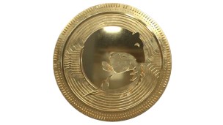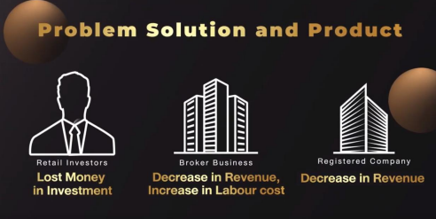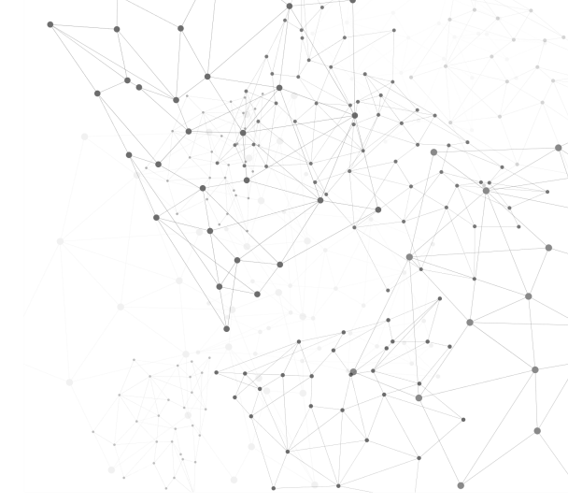

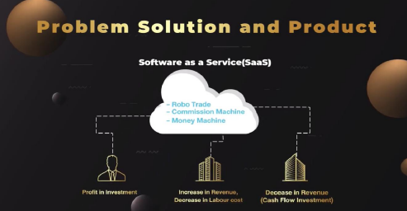

PolarBear X DeFi Robotics

The Ultimate All-in-one AI-driven Robot trading

and Platform for Global investors integrated

Blockchain-based on DeFi



Cloud

www.polarbear100x.co

TECHNOLOGY : ALGORITHMIC and QUANTITATIVE Trading based on Artificial Intelligence integrated Blockchain Technology

POLARBEAR X DEFI ROBOTICS

The Ultimate All-in-one AI-driven Robot trading and Platform for

Global investors integrated Blockchain-based on DeFi.

**PolarBear X DeFi Robotics** is Algorithmic trading and Quantitative trading

ecosystem in Stock, Mutual Funds, FX, Futures, and Cryptocurrency Market

based on Artificial Intelligence. With AutoCopyX technology, the ecosystem

can be scaled up to Hedge fund Robotics and DeFi ROBOBank based on

Blockchain technology, including Staking, Farming, Lending. This ecosystem

will interoperate to maximize returns while minimizing risks for Investors.

**PolarBear X DeFi Robotics** is Automating Fund Management Protocol, a Fully

Automated Investment decision-making system with no human intervention.

Our technology can help global investors grow their capital without deep

knowledge or experience of the market via auto-copy the AI-driven robot

trading, which connects to the FX bridge Futures Platform. It is an innovative

and friendly solution that enables global investors to get passive income with

minimum efforts and dividends using Staking.

www.polarbear100x.co

MARKET POTENTIAL : Global Financial Markets on Trillion-dollar Market Capitalization 

POWER OF RESEARCH AND DEVELOPMENT

AlgoQuant Lab

AlgoQuant Lab is a Research and Development in 100% Fully

Automated Robot Trading by using AI Technology in CME, COMEX

Futures products (No.1 of Derivatives Market) under SEC Thailand

with MTSGold (Licensed Broker’s Thailand) under PolarBear100X.

AlgoQuant Lab focuses on AI-Driven Robot trading on FX (CFD Equity

Indices), Gold spot (XAUUSD), Currencies, and Cryptocurrencies. And

also, research and develop Robo Advisor in the USA Stocks, Global

mutual funds applying machine learning algorithms to quantitative

trading to support Hedge fund Robotics managed FX, and Futures,

serving institutional and individual investors.

www.polarbear100x.co 

ROBOTICs Technology : Unlimited In-house Digital workforce as Human Workforce under FIFO Compliance (NFA) in the USA 

AI-ROBOTs (FX bridge Futures)

Real-time Performance (dynamically adapt to the Market )www.robolinked.me

Product and Service : Focus on Safety, Risk Management, Profitability on Up and Down Markets 

POWER OF SCALE UP

Social ROBO Investing Network

Social ROBO Investing Network (www.robolinked.me) is an innovative

cloud platform, hosting in Singapore using AutoCopyX Technology for

FX and Futures market. The AutoCopyX technology is capable of

integrating between Metatrader4 (FX Markets) and Metatrader5

(Futures market). It can be used to copy trade among different FX

Brokers to support Global Investors, Financial Firms, Hedge funds, and

Licensed FX Brokers such as Oanda, IG, IC Markets, XM, BDSwiss, GMIEdge, FBS, Exness , ROBOForex, MTSGold, and many more.



The ecosystem of Global FX and Futures Brokers 

Support Regulated Brokers for Scale up

www.robolinked.me

Performance : Expected Annual Return% > 30% and Return/Risk > 2 with Risk Automatic Protection (Stop loss Function)

AutoCopy X Technology for Copiers (Freemium-Trial 25 days)

Risk Management for Copiers

www.robolinked.me

BLOCKCHAIN INTEGRATION: Automating Fund Management Protocol, a Fully Automated Investment decision-making system 

POWER OF BLOCKCHAIN

Tokenization Benefits

PolarBear X DeFi Robotics Token (PBX) is a utility token used as a credit

for using copy trade service for Automated Trading Robots for FX and

Futures market on Social ROBO Investing Network (www.robolinked.me).

It is also used for DeFi Products for Staking Decentralized Exchange

(DEX) connected Crypto robot trading for spot and futures products. In

the future, the PBX token will be added to be Investment Token for Hedge

fund Robotics, Initial Exchange Offering (IEO) for Centralized Exchange

(CEX) on the Road Map.



www.polarbear100x.co

TOKEN Benefits : Passive Income Generator-Transaction fees and Automated Earning-Profit SharingBest Features 

PBX Token (PBX) is connected to Cutting-Edge DeFi Solution and

Trading autopilot among Financial markets

Ultra Fast & Secure Highly Scalable Reliable & Low Cost

Instant Transaction Limitless Financial Markets Profit Sharing / Staking

Smart contract is used for fund management protocol from Crypto Exchange connected to Financial markets

(Stock, FX, Futures)



AutoCopyX technology on Cloud is used for copy trading by global investors from FX bridging Futures and used for scale up to Hedge fund Robotics

(Stock, FX, Futures, Crypto Robot)

In-house R&D autopilot (Stock, FX, Futures,

Crypto Robot) using AL/ML which

dynamically adapt to the Market Get

redistribution fee without staking. Get

Profit Sharing and Dividends by Staking

(Annual Percentage Yield, APY)

www.polarbear100x.co

ECOSYSTEM : Increase Value of Tokens based on Demand and Transactions 

FOR UTILITY TOKEN ECOSYSTEM

FOR INVESTING TOKEN ECOSYSTEM



CRYPTO ECOSYSTEM

www.polarbear100x.co

COMPETITIVE LANDSCAPE : Total Innovative Service Solution on Traditional financial assets covering Crypto assets COMPETITOR ANALYSIS 

| **Features** | **POLARBEAR 100X** | **B-Cube.ai** | **Gunbot** | **3Commas** | **Crypto hoper** | **Napbot** |
| --- | --- | --- | --- | --- | --- | --- |
| FX- Automated Trading |  |  |  |  |  |  |
| CME-Automated Trading |  |  |  |  |  |  |
| COMEX - Automated Trading |  |  |  |  |  |  |
| USA- Stocks Robo Advisor |  |  |  |  |  |  |
| Global Mutual Funding using AI |  |  |  |  |  |  |
| Crypto DEX Trading |  |  |  |  |  |  |
| Crypto CEX Automated Trading |  |  |  |  |  |  |
| Advance ML & Quants |  |  |  |  |  |  |
| In-House Bots |  |  |  |  |  |  |
| Blockchain-based |  |  |  |  |  |  |
| Profit Sharing/Smart Contract |  |  |  |  |  |  |
| Mobile App |  |  |  |  |  |  |
| Marketplace |  |  |  |  |  |  |
| Staking |  |  |  |  |  |  |

Already Completed Work in Progress Not Implemented

www.polarbear100x.co

SALES and GROWTH Transaction : Subscription model varies Copiers depending on Marketing phase FINANCIAL FORECASTING (Subscription Model) 

Forecast Revenue (Baht) 

30,000,000

25,000,000 

20,000,000

**50%**

3 Model/month

15,000,000

10,000,000

5,000,000 

-

**1 Million$ AUM**

2 Model/month

1 Model/Month

Copier

10 100 500 1,000 2,000 3,000 5,000 Copier 1 2 3 4 5 6 7 

**10%**

**40%**

www.polarbear100x.co

TEAM-Integration of Finance, Engineering, and Business 



CEO Advisors

**Kittinu M**.,PhD. Candidate, EMBA, M.Eng 

-Financial Technology (AlgoQuant trading)

CTO COO

**Kiam A**., MBA, CCO

- Specialist in Improving Financial &



Commercial Practice and Performance Corporate Governance

**Phume Ng **Master of Mathematics, Statistics -AI and Machine Leaning -Blockchain Technology 

**Dr. Ronnakorn** V. PhD in Innovation Management - Innovation Ecosystem Builder -Incubator, Strategic advisor 

www.polarbear100x.co

Strategy/ Business Growth Roadmap : Scalp up strategy on Decentralized Exchange (DEX) to Centralized Exchange (CEX) TIMELINE ROAD MAP 



**$545.2K Funded**



**Crypto Copytrade**

**Series A Series B Series C**

www.polarbear100x.co

Contact Us 

Gmail : pbx@polarbear100x.coWhatsApp : (+66)967896394 Line : (+66)967896394 Facebook : PolarBear100X

PolarBear X DeFi Robotics 

Series-A investors and Strategic partners are Welcome

www.polarbear100x.co